

Lehrstuhl Elektrische Netze  
und Erneuerbare Energie

**Integrated Project**

**Demand Response for heating and cooling purposes in smart houses.**

am 01.08.2016 vorgelegte Integrated Projectt

von Abhik Ghosh

Erstprüfer: Prof. Dr.-Ing. habil. M. Wolter

Zweitprüfer: Prof. Dr.-Ing. A. Lindemann

Betreuer: Dr.-Ing.P Lombardi

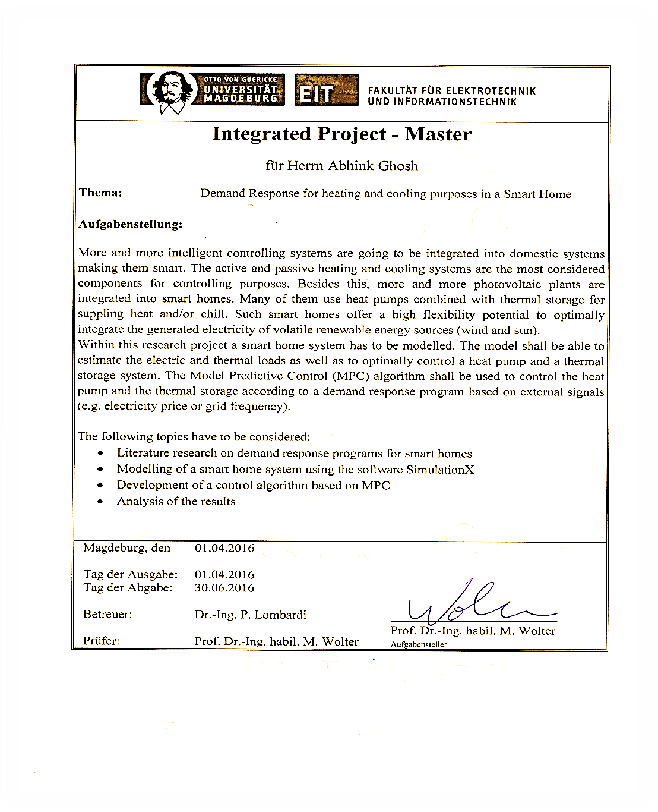

**Erklärung**

Ich versichere, dass ich diese Masterarbeit ohne fremde Hilfe selbstständig verfasst und nur die angegebenen Quellen und Hilfsmittel benutzt habe. Wörtlich oder dem Sinn nach aus anderen Werken entnommene Stellen sind unter Angabe der Quellen kenntlich gemacht.

01. Aug 2016

……………………………………………………..

Datum Unterschrift

###### Abstract

Demand response (DR) is an important aspect of the future smart grid. DR can be used to provide significant peak demand reduction and to ease the incorporation of renewable energy into the grid. Due to renewable energy and energy storage system, better demand response is needed . so that demand side also become flexible towards supply side. Demand response can better manage grid stablity and reduce the electrical prices.

Demand response of a household is important aspect of energy saving, as number of housing is increasing, so demand of power in housing area is on rise. In this study an economic analysis for household demand response is being done. The demand response based on pricing signal from grid is being studied and being compared with the without demand response condition.

In this study, a process of household heating and cooling system is designed using heat pump and fluid storage system. In this process demand response based on pricing function is implemented.

Based on the electricity power prices, algorithm is being devised to minimize the cost of heating and cooling. Evaluations of these algorithms is done via numerical simulations based on real world traces from production systems. The results show that using pricing algorithm and thermal inertia, there is a reduction of amount of energy used during peak hours and increase in the efficiency of energy. This way peak reduction and use of energy in peak hours can be reduced. Algorithm in household sector can be implemented which can drastically reduce the peak load of the grid and increase efficient use of energy. workload shifting in combination with local generation can provide significant cost savings (up to 8 % of consumer energy bill can be reduced annually under the Demand response scheme) compared to without demand response scheme.

###### Contents

[I Abstract I](#_Toc461392098)

[II Contents III](#_Toc461392099)

[III List of Figures. IV](#_Toc461392100)

[IV Abbreviations VI](#_Toc461392101)

[1 INTRODUCTION 1](#_Toc461392102)

[1.1 Motivation 1](#_Toc461392103)

[1.2 Objectives and contributions of this study. 1](#_Toc461392104)

[1.3 PROJECT OUTLINE 1](#_Toc461392105)

[2 MODELLING AND SIMULATION 2](#_Toc461392106)

[2.1 Simulation Software. 2](#_Toc461392107)

[2.2 MODELING 2](#_Toc461392108)

[2.2.1 Process 2](#_Toc461392109)

[2.2.2 Building zone. 4](#_Toc461392110)

[2.2.3 Heat Pump 6](#_Toc461392111)

[2.3 SIMULATION 7](#_Toc461392112)

[2.3.1 Simulation environment 7](#_Toc461392113)

[2.3.2 Simulation time 8](#_Toc461392114)

[2.3.3 Algorithm of Heat pump controller. 8](#_Toc461392115)

[2.3.4 Algorithm of Heat pump. 9](#_Toc461392116)

[2.3.5 Algorithm of Pricing function. 10](#_Toc461392117)

[2.3.5.1 Pricing function 10](#_Toc461392118)

[2.3.5.2 Algorithm 10](#_Toc461392119)

[3 Results 12](#_Toc461392120)

[3.1 TZone (Temperature inside the house) 12](#_Toc461392121)

[3.1.1.1 Without Demand response 12](#_Toc461392122)

[3.1.1.2 Demand response 12](#_Toc461392123)

[3.1.2 Long term Analysis (10 days’ analysis) 13](#_Toc461392124)

[3.1.2.1 Without Demand response 13](#_Toc461392125)

[3.1.2.2 Demand response 14](#_Toc461392126)

[3.2 Energy consumed. (Electrical energy and power consumed by grid) 15](#_Toc461392127)

[3.2.1 24 Hours analysis 15](#_Toc461392128)

[3.2.1.1 Without Demand response 15](#_Toc461392129)

[3.2.1.2 Demand response 16](#_Toc461392130)

[3.3 Total money paid by consumer (24 hours Analysis) 17](#_Toc461392131)

[3.3.1 Demand response 18](#_Toc461392132)

[3.3.2 10 days’ analysis 18](#_Toc461392133)

[3.3.2.1 Without Demand response 18](#_Toc461392134)

[3.3.2.2 Demand response 18](#_Toc461392135)

[3.4 Total money paid by consumer (10 days’ analysis) 19](#_Toc461392136)

[3.4.1 Without Demand response 20](#_Toc461392137)

[3.4.2 With Demand response 20](#_Toc461392138)

[3.5 Energy consumption and behavior of Pumps 20](#_Toc461392139)

[3.5.1 10 days Analysis 20](#_Toc461392140)

[3.5.1.1 Demand response 21](#_Toc461392141)

[3.5.2 24 hours Analysis 22](#_Toc461392142)

[3.5.2.1 Without Demand response 22](#_Toc461392143)

[3.5.2.2 Demand response 23](#_Toc461392144)

[3.6 Controller functionality 24](#_Toc461392145)

[3.7 Heat load of the house. 26](#_Toc461392146)

[4 CONCLUSION. 27](#_Toc461392147)

[5 References 28](#_Toc461392148)

[6 APPENDIX A (Commercial use is prohibited) 29](#_Toc461392149)

[6.1 Modelica code of volume coltroller with Demand response is shown: 29](#_Toc461392150)

###### List of Figures.

[Figure 1 Demand Response of Housing system in SimulationX. 3](#_Toc461667644)

[Figure 2 Private Household heating and cooling system. 4](#_Toc461667645)

[Figure 3 Private house model in which weather data is inserted [8] 4](#_Toc461667646)

[Figure 4 Ambient Temperature of Magdeburg (year 2010). 6](#_Toc461667647)

[**Figure 5** Heat pump process. 7](#_Toc461667648)

[Figure 6 Algorithm of Heat pump Controller. 8](#_Toc461667649)

[Figure 7 Algorithm of Heat pump. 9](#_Toc461667650)

[Figure 8 PRICE FUNCTION FOR A DAY [13]. 10](#_Toc461667651)

[Figure 9 Algorithm of Pricing function. 11](#_Toc461667652)

[Figure 10 Zonal temperature inside the house Vs ambient temperature (24 hours without demand response). 12](#_Toc461667653)

[Figure 11 Zonal temperature inside the house Vs ambient temperature.(24 hours with Demand response). 13](#_Toc461667654)

[Figure 12 Zonal Temperature inside the house Vs ambient temperature (10 days without Demand response). 14](#_Toc461667655)

[Figure 13 Zonal Temperature inside the house Vs ambient temperature (10 days with Demand response). 14](#_Toc461667656)

[Figure 14 Grids description(grid1 and grid2 ). 15](#_Toc461667657)

[Figure 15 Power and energy consumed by consumer from Grid 1 (24 hours without Demand response) 16](#_Toc461667658)

[Figure 16 Power and energy consumed by consumer from Grid 2 (24 hours without Demand response) 16](#_Toc461667659)

[Figure 17 Power and energy consumed by consumer from Grid 1 (24 hours with Demand response) 17](#_Toc461667660)

[Figure 18 Power and energy consumed by consumer from Grid 2 (24 hours with Demand response) 17](#_Toc461667661)

[Figure 19 Power and energy consumed by consumer from Grid 1 (10 days without Demand response) 19](#_Toc461667662)

[Figure 20 Power and energy consumed by consumer from Grid 1 (10 days with Demand response) 19](#_Toc461667663)

[Figure 21 Saving in electricity bill. 20](#_Toc461667664)

[Figure 22 Pump1 characteristics (10 DAYS WITHOUT Demand RESPONSE) (POWER, ENERGY and flow characteristics) 21](#_Toc461667665)

[Figure 23 Pump1 characteristics (10 days with Demand RESPONSE) (POWER, ENERGY and flow characteristics) 22](#_Toc461667666)

[Figure 24 Pump1 characteristics (24 hours without Demand RESPONSE) (POWER, ENERGY and flow characteristics) 23](#_Toc461667667)

[Figure 25 Pump1 characteristics (24 hours with Demand RESPONSE) (POWER, ENERGY, PRICING function and flow characteristics) 24](#_Toc461667668)

[Figure 26 Controller characteristics for 10 days in Demand response. 25](#_Toc461667669)

[Figure 27 Behavior of Temperature and flow incoming and return flow (10 days with Demand response). 25](#_Toc461667670)

[Figure 28 heat demand (power and ENERGY) inside the HOUSE DURING 10 days with Demand response. 26](#_Toc461667671)

###### Abbreviations

DR Demand Response.

P Power.

ESupply Electrical energy supplied by grid.

TZone Temperature of zone (inside house Temperature)

TAmbient Temperature of ambient.

CP circulation pump.

PCP Power consumed by circulation pump

ECP Electrical energy consumed by circulation pump.

qVRef Reference volume given by controller to the system.

EHeat Thermal energy required for heating or cooling inside the room.

QHeat Thermal power required for heating or cooling inside the room.

Pricing Pricing function which is either active or inactive depending on algorithm

Grid1 circulation pump and house heating is connected to grid 1 which use to supply required electrical energy and power to the system see Figure 14**.**.

Grid 2connects heat pump and circulation pump 2.

TMedium Temperature of the fluid (either upstream or downstream)

qvMedium Flow of the fluid (either upstream or downstream)

measureThermal3 Thermal measurement sensor for upstream fluid (going inside room).

measureThermal4 Thermal measurement sensor for downstream fluid (returning from room).

Volume controller Controls volume of reference flow to be given to pump.

# INTRODUCTION

## Motivation

Demand response (DR) is defined as: “the change in behavior of electricity consumption by end use customer from their normal electric consumption behavior in response to change in electricity price or electricity grid load” [1].

Demand response in private household sector has huge potential. In year 2011 , 140 TWh of electricity is being used in private household in Germany.. This is more than 25 percent of the electricity generated in Germany. The energy savings potential in industry is 40 TWh. Private households could rid themselves to a considerable degree of unnecessary energy costs. [2].

The private household can better use demand response to decrese the electricity billing price .DR in household sector can help in stabilising grid and incorporate renewable energy and storage system in the grid . So changes in the lifestyles of consumption can create a huge effect. In this study, this shown that using a price function algorithm in demand side , huge impact can be created in demand side management[1, 3–7].

## Objectives and contributions of this study.

The topic of this studyis “**Demand Response for heating and cooling purposes in smart houses”**. This research design models of house heating and cooling demand response and simulation of one-year analysis is being done based on Magdeburg weather data year 2010.

Specific objectives are:

* Modelling of smart home system using software SimulationX.
* Development of control algorithm based on electricity price.
* Analysis of the results.

## PROJECT OUTLINE

Chapter 1 gives Motivation and objectives of the study, Chapter 2 gives modeling and simulation. Chapter 4 shows the results of demand response and Chapter5 shows conclusion for this study

.

# ****MODELLING AND**** SIMULATION

## Simulation Software.

Software used to use modeling of the system are given below.

**SimulationX** is a program package for modelling, computation, simulation, optimization and reliability analysis of components and system in many areas of technological development. The software offers modeling tool, which permit to image all the physical-technological relationships in form of compounded elements. development. This software uses modelica language [8, 9].

**OPENMODELICA** is an open-source Modelica-based modeling and simulation environment intended for industrial and academic usage. Its development is supported by a non-profit organization the Open Source Modelica Consortium (OSMC) [10].

**Solver**

The **backward differentiation formula** (BDF) is a method for the numerical integration of ordinary differential equations. In this method, for a given function and time, approximate the derivative of that function using information from already computed times, thereby increasing the accuracy of the approximation. These methods are implement for the solution of stiff differential equations [8].

## ****MODELING****

SimulationX is used for analysis and simulation purpose. SimulationX provides in its Green building library,

### Process

In Figure 1**.**, private household heating and cooling system, the house model of floor space of $100 m^{2}$ and height of the zone is $2.7 m$ is taken where weather data for one year is the disturbance (which include ambient temperature, wind speed, wind direction, solar radiation and solar direct horizontal radiation) heat pump and controller, heat exchanger and storage is used to simulate one-year condition. Demand Response (price function algorithm) is used the process. The tariff is fixed contract based is assumed.

See Figure 1**.** for detailed process diagram in SimulationX. These process has following components.

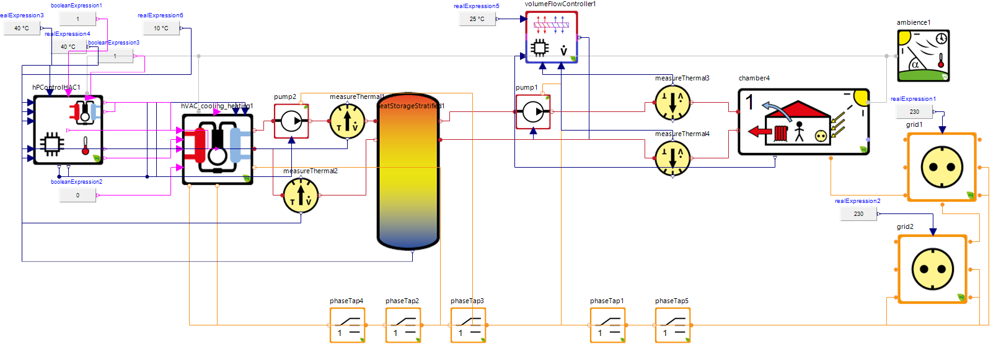

Figure 1 Demand Response of Housing system in SimulationX.

**Heat pump** use to either heat or cool as per the requirement in the zonal temperature of the room. In summer days, heat pump uses to cool the liquid and during winter days, Heat pump use to heat the liquid which include source pump, circulation pump and compressor.

Two **circulation pumps** are being used.

**Grid1** circulation pump and house heating is connected to grid 1 which use to supply required electrical energy and power to the system.

**Grid 2** connects heat pump and circulation pump 2.

**Heat storage** use to store the liquid which is pumped to either heat or cool the zonal temperature of the room.it acts as buffer storage.

**Controller** is designed to control the heating and cooling as per the zonal temperature requirement and Pricing requirement of grid.

**House model** is used from SimulationX green building which is designed very close too real model.

**Thermal and flow measurement sensor** are being used.

**Weather data** of Magdeburg of year 2010 is taken, in that ambient temperature, radiation, wind speed, wind direction and solar radiation diffusion data for one year is inserted see Figure 4.



Figure 2 Private Household heating and cooling system.

### Building zone.

The Building Zone model (Figure 3) simulates various disturbances on the internal temperature in a building (See Figure 3and Figure 4). Here influence of person on the heat demand and electricity needed is also taken into account. This building zonal model (one zone) can be coupled with others zones to make a complicated building system.[8].

The zone temperature depends on various disturbances:

* Heat transmission through walls, windows and other boundaries (e.g. doors) (qtrans)
* Solar yields (Qsun)
* Ventilation losses (qvent)
* Internal yields and losses via persons as well as electricity and water usage (qele, qperson)
* Internal heat storage (air, walls, inner masses) (Q)



Figure 3 Private house model in which weather data is inserted [8]

The following equations shows the behavior of various influences on house model.

|  |  |  |
| --- | --- | --- |
|  | $$Q=c_{p}*A*(T_{zone}-T_{ambient})$$ | (1) |

Where

$Q$ is the heat transferred per unit time.

$c_{p}$ is specific heat capacity.

$A$ is the area of the surface.

$T_{zone}$ is temperature inside the room.

$T_{ambient}$ is temperature of the atmoshpere.

$(T_{zone}-T_{ambient})$ is the temperature difference two surfaces where heat transfer s taking place.

|  |  |  |
| --- | --- | --- |
|  | $$Q_{sun}={∑g}_{c}*A*I$$ | (2) |

Where

$Q_{sun}$ is the heat transferred per unit time due to sun light.

$g_{c}$ is heat transfer coefficient.

$A$ is the area of the surface.

$I$ is rays incident on the surface with respect to time.

|  |  |  |
| --- | --- | --- |
|  | $$q_{trans}=U*A*(T_{zone}-T_{ambient})$$ | (3) |

Where

$q_{trans}$ is the heat transferred per unit time due to transmission losses.

$U$ is heat transmission value of boundry.

$A$ is the area of the surface.

|  |  |  |
| --- | --- | --- |
|  | $$q_{vent}=C_{p}*V_{air}*ß_{air}*(T_{zone}-T_{ambient})$$ | (4) |

Where

$q_{vent}$ is the heat transferred per unit time due to ventilation losses.

$V_{air}$ is volume of air from boundry.

$ß_{air}$ is rho i.e density of boundry.

$A$ is the area of the surface.

|  |  |  |
| --- | --- | --- |
|  | $${Q_{sun}+q_{elec}+q_{person}-q}_{vent}-q_{trans}=Q$$ | (5) |

Where

$q_{vent}$ is the heat transferred per unit time due to ventilation losses.

$Q_{sun}$ is the heat transferred per unit time due to sun incident rays.

$q_{elec}$ is the heat transferred per unit time due to electricity.

$q_{person}$ is heat transferred per unit time due to person.

$q_{trans}$ is heat transferred per unit time due to transmission losses.

$Q$ is heat transferred per unit time required to maintain zonal temperature

Figure 4 Ambient Temperature of Magdeburg (year 2010).

### Heat Pump

In heat pump, cooling or heating of fluid takes place which is built of six basic components compressor, source pump, expansion valve, Evaporator, condenser and circulation pump. The process work on vapor-compression refrigeration cycle.

**Compressor** use to increase pressure by reducing volume and use to transport fluid through pipe.

**Source pump** is an **air source heat pump** (ASHP) is a system which transfers heat from outside to inside a building, or vice versa. Under the principles of vapor compression refrigeration, an ASHP uses a refrigerant system involving a compressor and a condenser to absorb heat at one place and release it at another. They can be used as a space heater or cooler, and are sometimes called "reverse-cycle air conditioners" [11].

In household heating system, ASHP absorbs heat from outside air and releases it inside the building, as hot air, hot water-filled radiators, under floor heating and/or domestic hot water supply. The same system can often do the reverse in summer, cooling the inside of the house [11].

Circulation pump is a pump used to circulate liquids, or slurries in a closed circuit. these are used for circulating water in hydronic heating or cooling system. Because it only circulate liquid within a closed circuit, it only need to overcome the friction of a piping system [12].

There are two modes of working of heat pumps:

* In **heating mode,** evaporator is used as outer coil, while condenser is the indoor coil. The fluid gets heated in evaporator in which heat is added from external source (outside air or soil), this heated fluid is being carried by a pump to heat housing system through heat exchanger. Then fluid is going through expansion valve and condenser. This cycle is called vapor compression cycle where heat is added and removed as per the requirement.
* In **cooling mode,** the cycle is similar, but now condenser is the outdoor coil and evaporator is the indoor coil (which reaches a lower temperature). This is the familiar mode in which air conditioners operate.



**Figure 5** Heat pump process.

**Convection law**

|  |  |  |
| --- | --- | --- |
|  | $$Q=h_{c}*A*(T_{s}-T_{∞})$$ | (6) |

Where

$Q$ is the heat transferred per unit time.

$h_{c}$ is heat transfer coefficient.

$A$ is the area of the surface.

$T_{s}-T_{∞}$ is the temperature difference two surfaces where heat transfer s taking place.

## SIMULATION

Simulation for one-year data (Magdeburg year 2010 weather data) is done, both for Demand response and without Demand response. For analysis purpose 24 hours and 10 days (from ${190}^{th}$ day to ${200}^{th}$ day) simulation data are being used

### Simulation environment

* Windows 7 operating system.
* 2 GB RAM.
* Processor speed 3 GHz
* SimulationX 3.6.5 version

### Simulation time

7 hours is required for simulation of one year of data.

Structure of controller, heat pump and Pricing is given

### Algorithm of Heat pump controller.

In Heat pump controller algorithm see the price function along with the zonal temperature and give the required reference flow to source pump and circulation pump (see Figure 6). The output given to heat pump and pump is the reference flow and pricing signal depending on heating or cooling requirement. Based on ambient temperature (environmental temperature) and zonal temperature inside the house reference signal based on pricing function is given.



Figure 6 Algorithm of Heat pump Controller.

### Algorithm of Heat pump.

As per the reference flow obtained from the controller, the heat pump either acts in heating mode or cooling mode as per instruction from controller that’s also depend on demand response. The required energy is taken from grid 2.



Figure 7 Algorithm of Heat pump.

### Algorithm of Pricing function.

#### Pricing function

This is based on fixed contract. Four slot of pricing has been decided and paid according to that. Pricing function depending on reference price controls the price during peak hours and save money. Thermal intertie of room is being used here (see figure 7) [13].

Figure 8 PRICE FUNCTION FOR A DAY [13].

#### Algorithm

Design of demand response is designed as per pricing function such that when there is a peak load, the demand response takes into place and reduce the amount of energy taken from the grid.

Pricing algorithm is designed based on pricing function, if the current price of electricity is less than the reference price of the grid or consumer, then price is true and normal function of process takes place and ifpPrice is false then process halt depending on the limits of zonal temperature inside the room (see Figure 9). Here in current simulation price function (see Figure 7) becomes active when price is more than $200 euro/MWh$ unless it is inactive (Reference price is $200 euro/MWh)$.



Figure 9 Algorithm of Pricing function.

# Results

## TZone (Temperature inside the house)

Temperature inside a house of floor area of $100 m^{2}$ and height of $2.7m$ is shown for both demand response and without demand response 24 hours Analysis, The graph is taken for 1 day .Its on ${190}^{th}$ day of the year.

#### Without Demand response

Figure 10 shows that in without demand response temperature inside house remain constant because here all systems (pumps) are always working not depends on pricing function. Here pricing function is shown which as no affect on heatpump as in without demand response price function has no role.

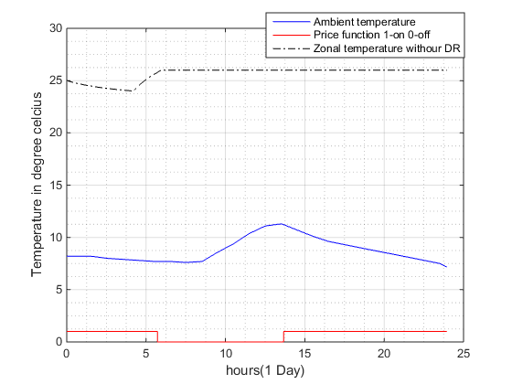

Figure 10 Zonal temperature inside the house Vs ambient temperature (24 hours without demand response).

#### Demand response

Figure 11 shows that in demand response thermal inertia is being used.In DR, House is heated or cooled (more or less than the reference temperature) as per requirement when electricity price is less and that extra thermal inertia is being used when electricity is more. The temperature inside the room varies between $24^{ }℃$ to $26^{\begin{aligned} \end{aligned}}℃$.Here heat pump and volume controller (pump1) works on price function. Due to this during peak load heatpump does not opertate and temperature inside the room decreases while when price is less, price function becomes active and heatpump operates to increase temperature till reference temperature .This utilizes price function and thermal inertia of the room to compensate the temperature inside the room.

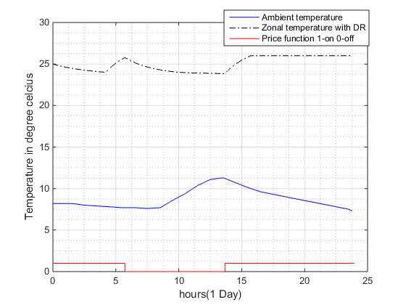

Figure 11 Zonal temperature inside the house Vs ambient temperature.(24 hours with Demand response).

### Long term Analysis (10 days’ analysis)

#### Without Demand response

Figure 12shows temperature inside the house remains constant at reference temperature despite variance in ambient temperature. The graph is taken for 10 days .Its starting from ${190}^{th}$ day to ${200}^{th}$ day of the year.

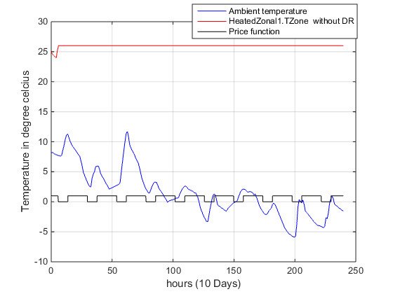

Figure 12 Zonal Temperature inside the house Vs ambient temperature (10 days without Demand response).

#### Demand response

Figure 13 shows that in demand response, temperature inside the house varies between $24^{ }℃$ to $26^{\begin{aligned} \end{aligned}}℃$. This uses price fuction , price function is active whenever the grid prices are less and inactive whenever grid prices are more. Based on price function the demand response becomes active or inactive.

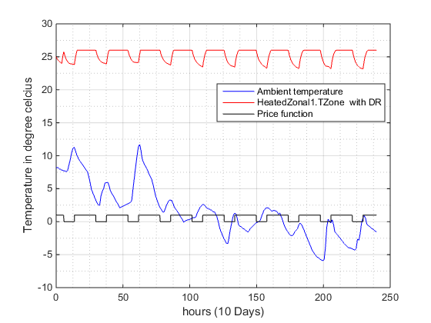

Figure 13 Zonal Temperature inside the house Vs ambient temperature (10 days with Demand response).

## Energy consumed. (Electrical energy and power consumed by grid)

In the proces, the Figure 14 shows that the system has two grids to supply energy.The house system and pump1 is connected to grid1. The heatpump and pump2 is connected to grid2. As grid produces the power and energy, the power and energy is taken positive.

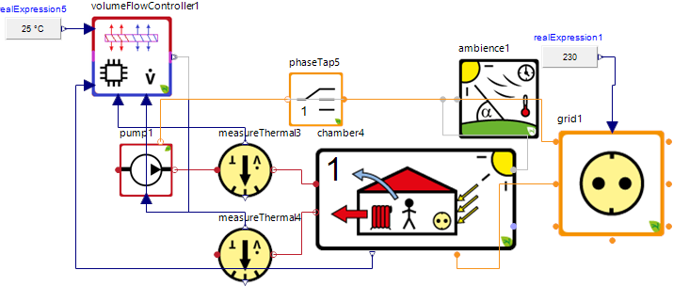

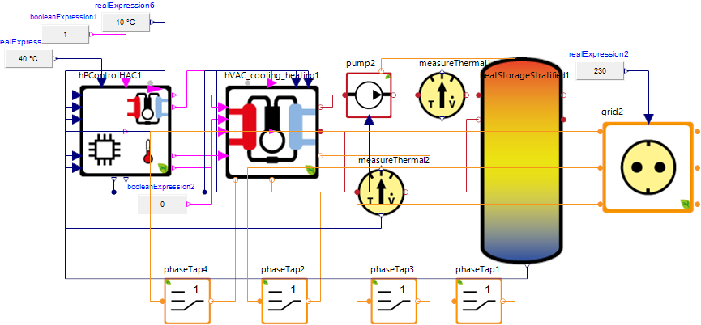

Figure 14 Grids description(grid1 and grid2 ).

### 24 Hours analysis

#### Without Demand response

Figure 15 and Figure 16 shows that amount of energy consumed by the pumps for heating/cooling of house. In the simulation pump1 is connected to grid 1 and pump2 is connected to grid 2. Amount of power and energy consumed is shown for 24 hours.

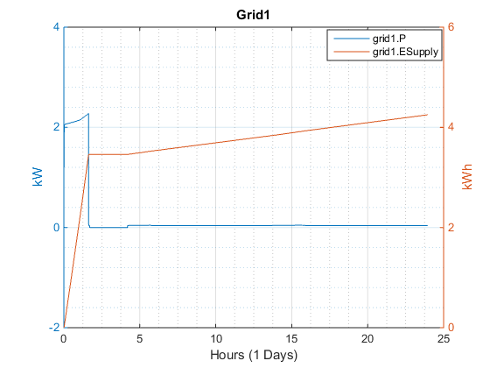

Figure 15 Power and energy consumed by consumer from Grid 1 (24 hours without Demand response)

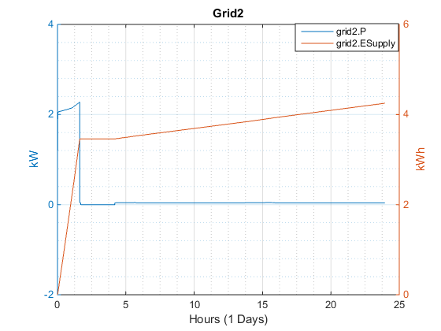

Figure 16 Power and energy consumed by consumer from Grid 2 (24 hours without Demand response)

#### Demand response

Amount of power consumed and amount of energy consumed is decreased by using demand response (pricing function). Figure 17 shows that the grid power and energy depends on price function. When price function is active grid gives power and when price function is inactive, it does not supply power. Moreover, amount of electricity needed for demand response is less than without demand response (see Figure 16).

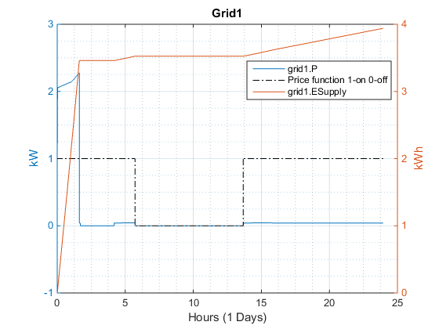

Figure 17 Power and energy consumed by consumer from Grid 1 (24 hours with Demand response)

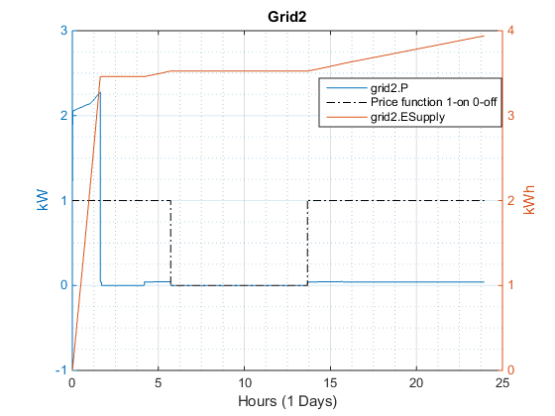

Figure 18 Power and energy consumed by consumer from Grid 2 (24 hours with Demand response)

## Total money paid by consumer (24 hours Analysis)

Total money paid in electricity bill = Amount of price from grid \*Amount of energy consumed.

$150\frac{€}{MWh}*3.49kWh+220\frac{€}{MWh}*0.34 kWh+190\frac{€}{MWh}*0.137 kWh+220\frac{€}{MWh}*0.278 kWh=68.5 cent$

Amount of money spent for electrical energy for **without demand response**

**= $68.5 cent$**

As there are two grids in the system . so total amount is $2*68.5 cent=1.37 €$

### Demand response

Assumption is made on Electricity bill calculation, effect of peak power consumption isnot taken into account.

Total money paid in electricity bill = Price from grid \*Amount of energy consumed=

$$150 €/MWh*3.6kWh+220 €/MWh*0.0 kWh+190 €/MWh*0.2 kWh+220 €/MWh*0.15 kWh=61.6 cent$$

Amount of money spent for electrical energy for **without demand response**

**= $62.6 cent$**

As there are two grids in the system . so total amount is $2*61.6 cent=1.22 €$

Amount of money saved in 24 hours = $1.37-1.22=15 cent$

So percentage of amount saved is $\frac{Electricity bill in without DR-electricity bill with DR}{ Electricity bill in without DR}\%= \frac{0.15}{1.372}=10.8\%$

### 10 days’ analysis

#### Without Demand response

Amount of electricity consumed is $12.8$ kWh and maximum of $2.3 kW$ of power.

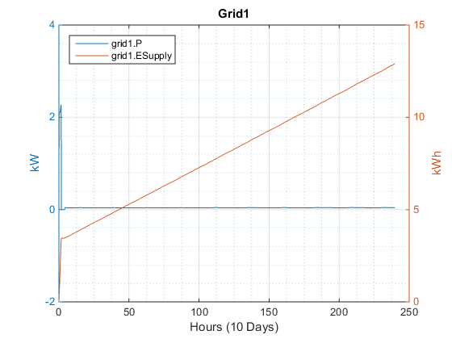

Figure 19 Power and energy consumed by consumer from Grid 1 (10 days without Demand response)

#### Demand response

Amount of electricity consumed is $12.9$ kWh and maximum of $2.3 kW$ of power.



Figure 20 Power and energy consumed by consumer from Grid 1 (10 days with Demand response)

## Total money paid by consumer (10 days’ analysis)

Figure 21 shows 10m days analysis of electricity bill in demand response and in without demand response .Saving in electricity bill due to demand response is shown in each daywise. The graph shows in the fluctuations of percentage saving for 10 days.

The following matlab code is used to find the amount of money spend for 10 days

www(:,1)=tzonedr(1:86500,1).\*24;

sss(:,1)=tzonedr(1:86500,1).\*24;

www(:,2)=B(1:86500,2);

sss(:,2)=A(1:86500,3);

for i = 1.000 :240.000

k (i)= www(i \* 360,2)% demand response data

h(i)= sss(i \* 360,2)% without demand response data

end

for i=0:9 %calculte price of electricity

c(1+i)= 150\*(h(24\*i+6)-h(24\*(i-1)+24))+220\*(k(24\*i+13)-k(24\*i+6))+190\*(k(24\*i+17)-k(24\*i+13))+ 150\*(k(24\*i+24)-k(24\*i+17))

d(i+1)= 220\*(h(24\*i+13)-h(24\*i+6))+190\*(h(24\*i+17)-h(24\*i+13))+ 150\*(h(24\*i+24)-h(24\*i+17))

end

withoutdr=sum(c)+150\*k(6)

dr=sum(d)+150\*h(6)

Figure 21 Saving in electricity bill.

### Without Demand response

Amount of money spend without demand response is $2.23 €$ (Grid 1)

As there are two grids in the system . so total amount is $2*2.23 €=4.46€$

### With Demand response

Amount of money spend without demand response is $2.17 €$ (Grid 1)

As there are two grids in the system . so total amount is $2*2.17 € =4.34 €$

Amount of money saved in 10 days = $\left(4.46-4.34\right)=0.12€$

So percentage of amount saved is $\frac{0.12}{4.46}=2.7\%$

## Energy consumption and behavior of Pumps

### 10 days Analysis

Figure 21 and Figure 22 shows how pump behaves. Figure 22 shows that during Demand response the flow of the pump is varied as per pricing function whereas Figure 21 shows that flow is not being controlled as per pricing function.

Here power and energy consumed by pump is negative as pump use to consume power and energy.wheareas in grid power and energy produced is positive.

Figure 21 shows that flow of the pump 1 in without demand response is varies from (steady state) $0.15 to 0.25 m^{3}/h$ but in Figure 22 shows that in demand response depending on pricing function flow of the pump varies from $0 to 0.7 m^{3}/h$. Due to this difference in the flow, the energy consumption in Demand response is slightly higher but as energy consumption is done during non-peak time of the grid.

sB:\Desktop\pump1_volume.emf

Figure 22 Pump1 characteristics (10 DAYS WITHOUT Demand RESPONSE) (POWER, ENERGY and flow characteristics)

#### Demand response

Figure 22 shows the flow of pump1 varies with price function . As price function varies, the power and energy consumed by the pump also varies. Detailed figure is given to show the variation of flow and power or energy on price function.

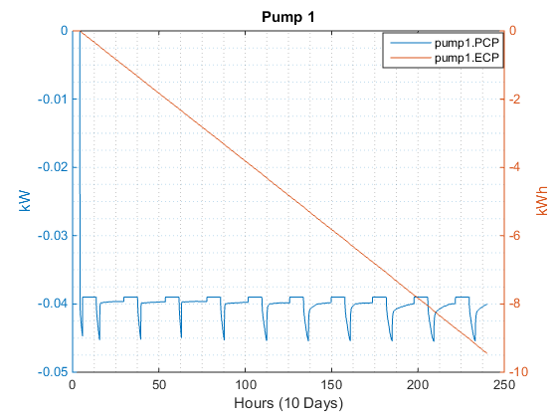

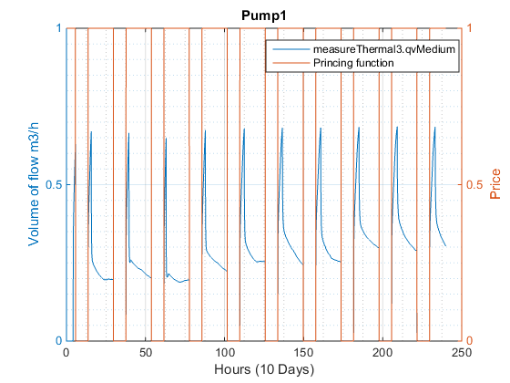

Figure 23 Pump1 characteristics (10 days with Demand RESPONSE) (POWER, ENERGY and flow characteristics)

### 24 hours Analysis

Figure 23 and Figure 24 shows how pump behaves.

There is difference in 24 hours’ analysis than 10 days’ analysis, here the amount of energy consumed in demand response is less compare without demand response.

Here power and energy consumed by pump is negative as pump use to consume power and energy.wheareas in grid power and energy produced is positive.

#### Without Demand response

Figure 24shows that during Demand response the flow of the pump is varied as per pricing function whereas Figure 23 shows that flow is not being controlled as per pricing function.

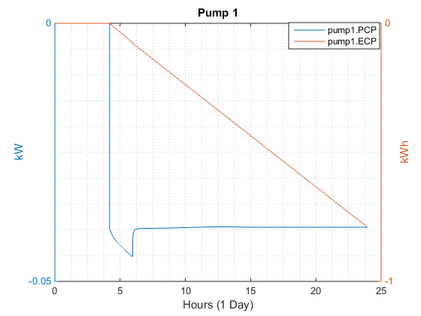

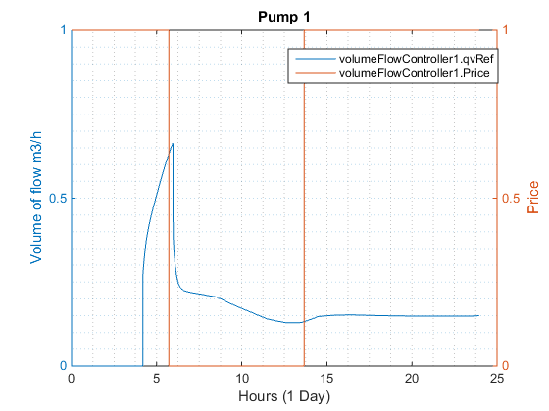

Figure 24 Pump1 characteristics (24 hours without Demand RESPONSE) (POWER, ENERGY and flow characteristics)

#### Demand response

Figure 24shows the pricing function varies the amount of flow and electrical energy consumed during peak load. Depending upon flow both power consumption and energy used varied. The detailed Figure 24 shows the variation of flow with price function.when price function is active then pump give flow unless thereis no flow. The variation of power or energy along with the price function is also shown.

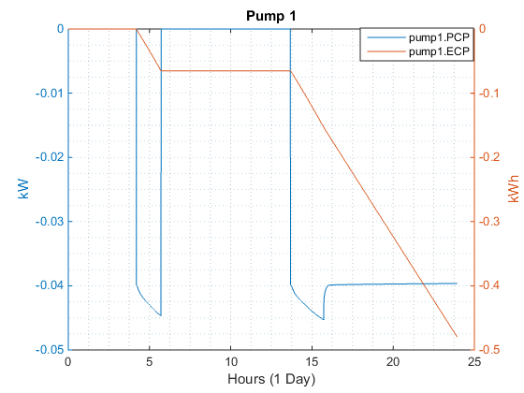

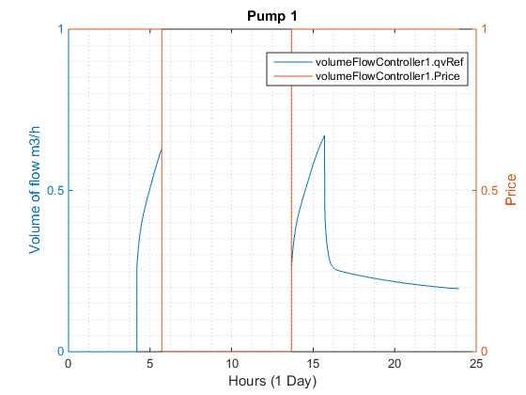

Figure 25 Pump1 characteristics (24 hours with Demand RESPONSE) (POWER, ENERGY, PRICING function and flow characteristics)

## Controller functionality

Figure 25 shows the demand response (variation of reference flow) given to pump varies as per pricing function. When pricing function is action then reference flow is given as per requirement of the house.



Figure 26 Controller characteristics for 10 days in Demand response.

Figure 26 **Behavior of Temperature and flow incoming and return flow (10 days with Demand response).** Figure 26 shows that the upstream fluid flows at temperature at $40℃$ and return fluid is at temperature varies from $33℃ to 24℃$.The amount of flow also varies from

measurement

Figure 27 Behavior of Temperature and flow incoming and return flow (10 days with Demand response).

## Heat load of the house.

Figure 27 shows demand response of house system in which heat demand (power and energy) is given. The variation of heat demand as per pricing function is totally visible. During active pricing function, its add zero heat demand and adjusted when pricing function is inactive .

C:\Users\abhik\AppData\Local\Microsoft\Windows\INetCacheContent.Word\heated zone.emf

Figure 28 heat demand (power and ENERGY) inside the HOUSE DURING 10 days with Demand response.

# CONCLUSION.

In this study, the demand response of housing system which is based on external signal (a pricing signal based) is being analyzed. Comparison has been between Demand response and without demand response housing system. Economic analysis shows that Demand response saves around $8 \%$ of consumer bill. Although sometime there is no much of difference in energy saving but due to demand response of peak load, lots of money can be saved and efficient use of energy can be done.

As per German Energy transition website, in 2015, the average German household power bill fell slightly from 85 euros to 84 euros per month [14]. Demand response can save around $5 €$ per month in electricity bill which annually saves around $60 € per annum$. per household.

Although demand response, increases non-linearity of the system but better controller can decrease this non-linearity or handle it in a better way. In future work, better and advance controller based on MPC and neutral network can be implemented.

# References

[1] Power & Energy Society; IEEE PES Innovative Smart Grid Technologies Conference - India; IEEE PES International Conference on Innovative Smart Grid Technologies - India; IEEE PES ISGT India, *2011 IEEE PES innovative smart grid technologies - India (ISGT India 2011): [conference] ; Kollam, Kerala, India, 1 - 3 December 2011*. Piscataway, NJ: IEEE, 2011.

[2] Internetseite des Bundesumweltministeriums - BMUB, *General Information.* [Online] Available: http://www.bmub.bund.de/en/topics/climate-energy/energy-efficiency/general-information/#. Accessed on: Aug. 19 2016.

[3] D. Al-Dabass, Ed, *2010 Second International Conference on Computational Intelligence, Modelling and Simulation, (CIMSiM): 28 - 30 Sept. 2010, Bali, Indonesia*. Piscataway, NJ: IEEE Service Center, 2010.

[4] Institute of Electrical and Electronics Engineers; Power & Energy Society; IEEE PES Innovative Smart Grid Technologies Conference; ISGT, *IEEE PES Innovative Smart Grid Technologies Conference (ISGT), 2013: 24 - 27 Feb. 2013, Washington, DC*. Piscataway, NJ: IEEE, 2013.

[5] Power Engineering Society; IEEE Power Engineering Society (PES) general meeting, *IEEE Power Engineering Society general meeting, 2007: 24 - 28 June 2007, [Tampa, FL]*. Piscataway, NJ: IEEE Service Center, 2007.

[6] J. Torriti, *Peak energy demand and demand side response*. London, New York NY: Routledge Taylor & Francis Group, 2016.

[7] Wikipedia, *Demand response - Wikipedia, the free encyclopedia.* Accessed on: Aug. 19 2016.

[8] u. behnert, “SimulationX 3,”

[9] *Modeling and Simulation of Technical Systems | ITI.* [Online] Available: https://www.simulationx.com/. Accessed on: Aug. 19 2016.

[10] Administrator, *Welcome to OpenModelica - OpenModelica.* [Online] Available: https://www.openmodelica.org/. Accessed on: Aug. 19 2016.

[11] Wikipedia, *Air source heat pumps - Wikipedia, the free encyclopedia.* [Online] Available: https://en.wikipedia.org/w/index.php?oldid=697878311. Accessed on: Aug. 19 2016.

[12] Wikipedia, *Circulator pump - Wikipedia, the free encyclopedia.* [Online] Available: https://en.wikipedia.org/w/index.php?oldid=700886174. Accessed on: Aug. 19 2016.

[13] *Price in Germany | Energy Charts.* [Online] Available: https://www.energy-charts.de/price.htm. Accessed on: Aug. 19 2016.

[14] *German Energy Transition.* [Online] Available: http://energytransition.de/. Accessed on: Aug. 19 2016.

# APPENDIX A (Commercial use is prohibited)

## Modelica code of volume coltroller with Demand response is shown:

model VolumeFlowController "VolumeFlowController.mo"  
 GreenBuilding.Interfaces.Ambience.AmbientCondition AmbientConditions "Ambient Conditions Connection" annotation(  
 Placement(  
 transformation(extent={{112,-129},{152,-89}}),  
 iconTransformation(extent={{-70,130},{-30,170}})),  
 Dialog(  
 group="Temperature",  
 tab="Results",  
 showAs=ShowAs.Result));  
 input Modelica.Blocks.Interfaces.RealInput TRef(  
 quantity="Thermics.Temp",  
 displayUnit="°C") "Reference temperature" annotation(  
 Placement(  
 transformation(extent={{112,-129},{152,-89}}),  
 iconTransformation(extent={{-170,80},{-130,120}})),  
 Dialog(  
 group="Temperature",  
 tab="Results",  
 showAs=ShowAs.Result));  
 input Modelica.Blocks.Interfaces.RealInput TAct(  
 quantity="Thermics.Temp",  
 displayUnit="°C") "Actual temperature" annotation(  
 Placement(  
 transformation(  
 origin={246,-195},  
 extent={{-20,-20},{20,20}},  
 rotation=90),  
 iconTransformation(  
 origin={-150,-100},  
 extent={{-20,-20},{20,20}})),  
 Dialog(  
 group="Temperature",  
 tab="Results",  
 showAs=ShowAs.Result));  
 input Modelica.Blocks.Interfaces.RealInput TReturn(  
 quantity="Thermics.Temp",  
 displayUnit="°C") if not useStandardTempDiff "Actual return temperature" annotation(  
 Placement(  
 transformation(  
 origin={330,-55},  
 extent={{-20,-20},{20,20}},  
 rotation=-90),  
 iconTransformation(  
 origin={50,-150},  
 extent={{-20,-20},{20,20}},  
 rotation=90)),  
 Dialog(  
 group="Temperature",  
 tab="Results",  
 showAs=ShowAs.Result));  
 input Modelica.Blocks.Interfaces.RealInput TFlow(  
 quantity="Thermics.Temp",  
 displayUnit="°C") if not useStandardTempDiff "Actual flow temperature" annotation(  
 Placement(  
 transformation(  
 origin={235,-55},  
 extent={{-20,-20},{20,20}},  
 rotation=-90),  
 iconTransformation(  
 origin={-50,-150},  
 extent={{-20,20},{20,-20}},  
 rotation=90)),  
 Dialog(  
 group="Temperature",  
 tab="Results",  
 showAs=ShowAs.Result));  
 output Modelica.Blocks.Interfaces.RealOutput qvRef(  
 quantity="Thermics.VolumeFlow",  
 displayUnit="m³/h") "Reference volume flow" annotation(  
 Placement(  
 transformation(extent={{547,-113},{567,-93}}),  
 iconTransformation(extent={{140,-10},{160,10}})),  
 Dialog(  
 group="Volume Flow",  
 tab="Results",  
 showAs=ShowAs.Result));  
 parameter Real EPriceAvg=48;  
 Modelica.Blocks.Tables.CombiTable1D EPricing(  
 tableOnFile=true,  
 tableName=CPTable,  
 fileName=HPFile) "Electrical price circulation pump" annotation(  
 Placement(transformation(extent={{-10,-10},{10,10}})),  
 Dialog(  
 group="Coefficient of Performance",  
 tab="Results 1"));  
 parameter String HPFile=GreenBuilding.Utilities.Functions.getModelDataDirectory()+"\\heat\_pump\\hp\_data\\Stiebel\_Eltron\\WPL\_10\_ACS\\SE\_WPL\_10\_ACS1.txt" "File name for heat pump characteristics" annotation(Dialog(  
 group="Heating Power",  
 tab="price - Power Data"));  
 parameter String CPTable="Pricing" "Table name for Eprice behavior" annotation(Dialog(  
 group="Power Data",  
 tab="eprice"));  
 Boolean Price "Price based model state on/off" annotation(Dialog(  
 group="I/O",  
 tab="Results 1",  
 showAs=ShowAs.Result));  
 Boolean ONheat "Switch-ON/OFF for heat controller" annotation(Dialog(  
 group="Control",  
 tab="Results",  
 showAs=ShowAs.Result));  
 Boolean ONcool "Switch-ON/OFF for cooling controller" annotation(Dialog(  
 group="Control",  
 tab="Results",  
 showAs=ShowAs.Result));  
 parameter Real deltaTCoolBound=3 "Cooling boundary temperature difference" annotation(Dialog(  
 group="Heating/Cooling Control",  
 tab="Parameters"));  
 parameter Real deltaTHeatBound=0 "Heating boundary temperature difference" annotation(Dialog(  
 group="Heating/Cooling Control",  
 tab="Parameters"));  
 parameter Real deltaTupHeat(  
 quantity="Thermodynamics.TempDiff",  
 displayUnit="K")=1 "Upper temperature difference for heating (heat power = 0)" annotation(Dialog(  
 group="Temperature Control",  
 tab="Parameters"));  
 parameter Real deltaTlowHeat(  
 quantity="Thermodynamics.TempDiff",  
 displayUnit="K")=-1 "Lower temperature difference for heating (heat power = max)" annotation(Dialog(  
 group="Temperature Control",  
 tab="Parameters"));  
 parameter Real deltaTupCool(  
 quantity="Thermodynamics.TempDiff",  
 displayUnit="K")=1 "Upper temperature difference for cooling (cooling power = max)" annotation(Dialog(  
 group="Temperature Control",  
 tab="Parameters"));  
 parameter Real deltaTlowCool(  
 quantity="Thermodynamics.TempDiff",  
 displayUnit="K")=-1 "Lower temperature difference for cooling (cooling power = 0)" annotation(Dialog(  
 group="Temperature Control",  
 tab="Parameters"));  
 parameter Real cpMed(  
 quantity="Thermics.SpecHeatCapacity",  
 displayUnit="kJ/(kg·K)")=4177 "Specific heat capacity of heating medium" annotation(Dialog(  
 group="Medium",  
 tab="Parameters"));  
 parameter Real rhoMed(  
 quantity="Thermics.Density",  
 displayUnit="kg/m³")=1000 "Densitiy of heating medium" annotation(Dialog(  
 group="Medium",  
 tab="Parameters"));  
 parameter Real QHeatMax(  
 quantity="Basics.Power",  
 displayUnit="kW")=5000 "Maximum heating power" annotation(Dialog(  
 group="Heating Power",  
 tab="Parameters"));  
 parameter Real QCoolMax(  
 quantity="Basics.Power",  
 displayUnit="kW")=5000 "Maximum cooling power" annotation(Dialog(  
 group="Heating Power",  
 tab="Parameters"));  
 parameter Real qvMax(  
 quantity="Thermics.VolumeFlow",  
 displayUnit="m³/h")=0.00055555555555555556 "Maximum volume flow for heating system" annotation(Dialog(  
 group="Volume Flow",  
 tab="Parameters"));  
 initial equation  
 //assert(deltaTupCool>deltaTlowCool,"Upper temperature limit must be higher than lower one");  
 //assert(deltaTHeatBound+deltaTupHeat<deltaTCoolBound+deltaTlowCool, "Heating boundary must be lower than cooling boundary");  
   
 if (TAct>(TRef+deltaTlowCool)) then  
 ONcool=true;  
 ONheat =false;  
 else  
 ONheat =true;  
 ONcool=false;  
 end if;  
 equation  
 EPricing.u[1] = AmbientConditions.HourOfDay;  
 if ( EPriceAvg > EPricing.y[1] ) then  
 Price = true;   
 else   
 Price=false;  
 end if;   
   
   
 when ((AmbientConditions.TAmbient-TRef)<deltaTlowHeat) then  
   
 ONheat =true;  
 ONcool=false;  
 elsewhen ((AmbientConditions.TAmbient-TRef)>deltaTupHeat) then  
 ONheat =false;  
 ONcool=false;  
 elsewhen ((AmbientConditions.TAmbient-TRef)>deltaTupCool) then  
 ONheat =false;  
 ONcool=true;  
 elsewhen ((AmbientConditions.TAmbient-TRef)<deltaTlowCool) then  
 ONheat =false;  
 ONcool=false;  
 end when;   
   
 if ( ONcool and Price ) then  
   
 qvRef=max(min(max(((TAct-TRef-deltaTupCool)\*qvMax/(deltaTupCool-deltaTlowCool)),0),qvMax), QCoolMax/(cpMed\*rhoMed\*max((TFlow-TReturn),0.1)));  
   
 elseif ( ONheat and Price ) then  
 qvRef=max(min(max(((TRef+deltaTupHeat-TAct)\*qvMax/(deltaTupHeat-deltaTlowHeat)),0),qvMax), QHeatMax/(cpMed\*rhoMed\*max((TFlow-TReturn),0.1)));  
 else  
 qvRef=0;  
 end if;

end VolumeFlowController